# General information

This testbed package encompasses all files necessary to run the Eldorado Utility Planning Model (EUPM) in multiple different hydrologic futures while altering the configuration of a hypothetical utility’s system. The utility’s system can be evaluated using many pre-defined performance measures captured in multiple RW slots, and the various performance measures can be output in several formats. This package only contains files that support running the model interactively (no automated simulation directed by an outside executable), but the model is set up to simulate multiple hydrologic traces concurrently through the use of various MRMs.

The EUPM is designed to run in the “inline rulebased with accounting” RW mode. This means that it requires a set of policies to direct interactions and calculations within the modeled water supply network and that, along with physical water balancing across structures and users, the water is also divided into different accounting streams within physical objects in order to distribute water according to ownership (and other considerations).

The inaugural use for EUPM was in a Multiobjective Evolutionary Algorithm (MOEA) optimization study. As such, many of the input and output structures were designed for this purpose (though some were modified for more general use before making the model publically available). However, at its core it is simply a multireservoir simulation model that can be tailored to any use. The model will run without needing to load any inputs because there is a set pre-loaded. However, the model is currently structured to accept hydrologic inputs for different scenarios. With some RW skill, a user can create fully customized slot calculations and write rules that alter how water users demand, divert, and store water and how they interact with other users and available supply.

## Suggested knowledge

EUPM creators suggest using RW help documents, training classes, and other models in order to familiarize yourself with the following: opening and running a RW model that uses rulebased simulation; understanding how rules impact simulations, how to read them, and how to search them for specific phrases or slots; general concepts of input and output DMIs; general concept of MRMs; and the general concept of water accounting, how it interacts with simulation, and how it is represented in the model view.

## File structure and running the model

The Eldorado Utility Planning Model (EUPM) is captured in the “Eldorado.Public.V2.mdl” file, which was last saved in RW version 7.2; thus, users will need at least this version of RW or later to open the model.

The testbed package is structured in the exact way necessary to make use of the input and output features built into the model. (This includes the existence of some empty folders, the hierarchies of different folders, the locations of specific files, etc.) The only thing you need to do to get started is to create an Environment Variable on your computer that directs a variable called “ELDO” to the path of the testbed directory. Once this is done, everything within the model should work.

# Rules

The default ruleset is automatically loaded when you open the model and this set is identical to the “$ELDO/Eldorado.Public.8.17.17.RW7.2.rls” that came with the modeling package.

# Accounting

This model uses accounting to track ownership and reusability of water. The accounting incorporates priority dates in order to simulate the prior appropriation legal doctrine that controls water in Colorado.

# Model description

This content is taken from a draft of a journal article. It is not necessary to read this, but it will help you understand the bigger picture of the model structures and functions.

The EUPM was created based on the water management context of a small utility in the Front Range region of Colorado. The Front Range is an urban corridor located just east of the Rocky Mountains. It experiences complex water management challenges common to much of the western U.S. Below, some of the major dynamics will be briefly introduced alongside general model features that capture them. After the model introduction, *Eldorado Utility* will provide details about the hypothetical utility’s system and then *Other Model Features* will describe how that system interacts with the other features of the model. For more in-depth information about Colorado water management context see the Colorado State Water Plan (State of Colorado, 2015) and Smith et al (2017).

In Colorado, water resources are geographically divided by the Rocky Mountains, with 70% of the water originating on the west slope. Because 80% of the population lives on the east slope (predominantly along the Front Range) (State of Colorado, 2015) and the eastern rivers have been overallocated for over 100 years (Caulfield Jr. et al., 1987; P. O. Abbott, 1985), water utilities usually draw water from multiple eastern and western slope rivers. For this reason, the EUPM is regional in scale. It encompasses two major basins on either side of a mountain range; each major basin has multiple sub basins for a total of five distinct streams. These correspond to five headwaters streamflow sites in the model which require monthly timeseries inputs.

As in most of the western U.S., the right to use water in Colorado is governed by the prior appropriation doctrine. This means that water is allocated based on the historic dates on which entities used or declared their intention to store or divert specific volumes or rates of water. When there is not enough water in a stream to satisfy all water rights, junior users’ supplies are reduced or cut off completely. The EUPM captures the competition for water under this legal scheme by explicitly modeling multiple water users across the basins that have a wide range of water rights dates (priorities). Several sectors are represented: agricultural, industrial, municipal, and environmental; the sectors have different use patterns and different rates of consumption and return flows. The users in the EUPM are staggered across basins throughout the model because water right yield is greatly impacted by physical location of the right relative to other water users’ diversions and return flows.

Some types of water rights in Colorado are reusable. When a utility uses water from a reusable source, it can obtain the right to re-divert (or “exchange”) upstream any unconsumed water from that source that is returned to the stream as long as doing so does not injure more senior water right holders. Tracking multiple users’ nuanced water ownership through time and space is a complex and critical aspect of modeling Colorado and western U.S. water resources dynamics. The EUPM is able to include this functionality through the water accounting features of the RiverWare modeling platform (Zagona et al., 2001).

Further discussion of the EUPM is supported by the schematic of the model shown in Figure 1 and the water user information found in Table 1. Bolded acronyms given in parentheses correspond to objects in the figure and table.

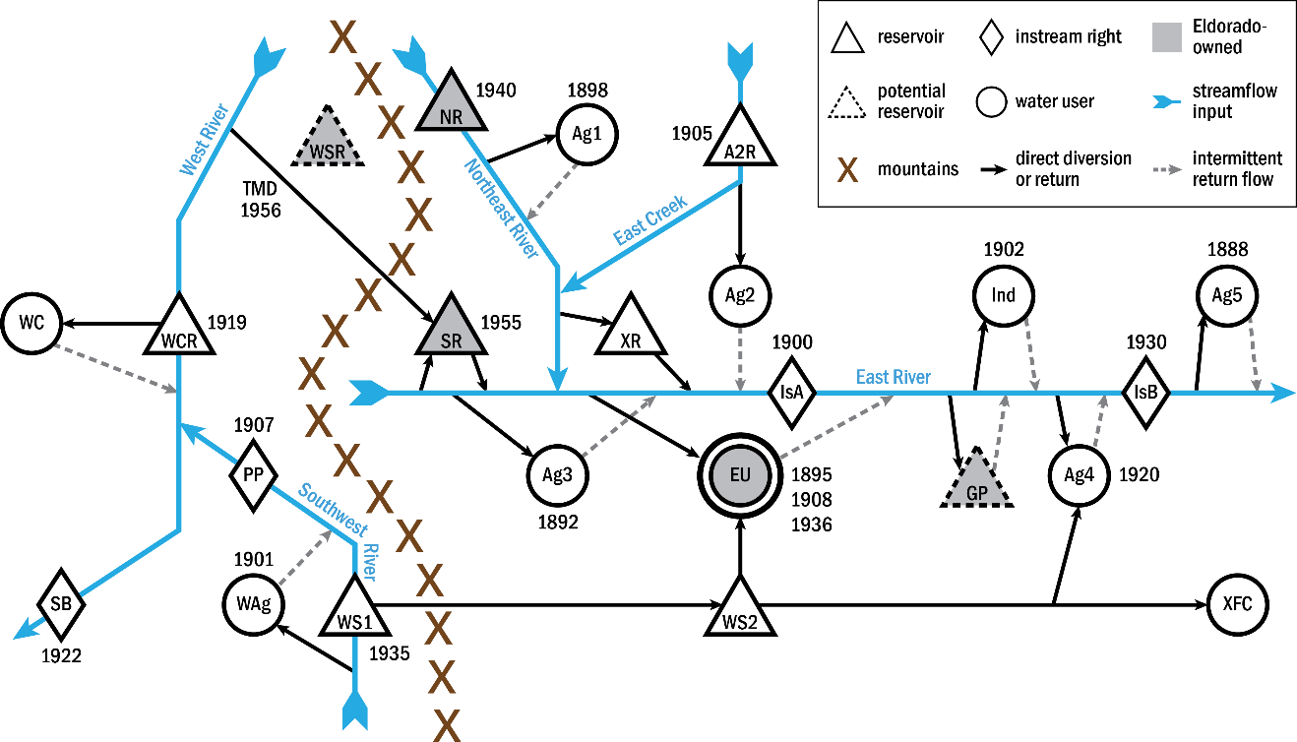

Figure 1. Schematic of the Eldorado Utility Planning Model. Many different users on both slopes of the mountain range impact Eldorado’s ability to collect and divert water via their priority dates, the locations of their diversions, and the locations of their return flows (precise diversion and return flow locations are indicated by arrows). Each user or right in the diagram has a priority date associated with it where applicable and is listed in Table 1.

Table 1. Detail for water users and reservoirs in Eldorado Utility Planning Model. Abbreviations refer to those found in Figure 1. The order of users going down each table column corresponds approximately to reading left-to-right on the diagram. Eldorado Utility’s rights and reservoirs are in bold. Superscripts in the table are defined as follows: ARes = Reservoir; BMCM = million cubic meters; CKAF = thousand acre feet; DAg = Agriculture; Ecms = cubic meters per second; Fcfs = cubic feet per second.

|  |  |  |  |  |  |  |  |  |  |  |
| --- | --- | --- | --- | --- | --- | --- | --- | --- | --- | --- |
| **Abbr.** | **Name** | **RW Object** | **Priority Date** | **Magnitude of Rights** |  | **Abbr.** | **Name** | **RW Object** | **Priority Date** | **Magnitude of Rights** |
| SB | Southern Basin | LowerBasin | 1922 | varying flow |  | XR | External Res | ExtrenalRes | N/A | varying vol |
| WC | Western City | WestSlopeMunicipal | N/A | n/a |  | A2R | Ag2 Irrigation Co. Res | Ag2Res | 1905 | 24.7 MCM (20 KAF) |
| WCR | Western City ResA | WestSlopeMunicipalRes | 1919 | 24.7 MCMB (20 KAFC) |  | Ag2 | Ag2 User | Ag2 | N/A | n/a |
| WAg | Western AgD User | WestSlopeAg | 1901 | 4.3 cmsE (150 cfsF)  seasonal |  | **EU** | **Eldorado Utility** | **Utility** | **1895**  **1908**  **1936** | **0.28 cms (10 cfs);**  **0.34 cms (12 cfs);**  **0.42 cms (15 cfs)** |
| PP | Power Plant | PowerPlant | 1907 | varying flow |  | WS2 | Wholesaler Res 2 | WholesalerRes2 | N/A | 123.3 MCM (100 KAF) |
| **TMD** | **TransMtn Diversion** | **UtiltyTMD1** | **1956** | **2.2 cms (80 cfs)** |  | IsA | Instream Flow A | InstreamA | 1900 | varying flow |
| **WSR** | **West Slope Res** | **WestSlopeRes** | **1956** | **varying vol** |  | **GP** | **Gravel Pit** | **GravelPit** | N/A | **1.0 MCM (800 AF)** |
| WS1 | Wholesaler Res1 | WholesalerRes1 | 1936 | 616.7 MCM (500 KAF) |  | Ind | Industrial User | Industrial | 1902 | varying flow |
| **NR** | **North Res** | **Res1** | **1940** | **11.1 MCM (9 KAF)** |  | Ag4 | Ag User 4 | Ag4 | 1920 | 1.4 cms (50 cfs)  seasonal |
| **SR** | **South Res** | **Res2** | **1955** | **9.9 MCM (8 KAF)** |  | IsB | Instream Flow B | InstreamB | 1930 | 0.42 cms (15 cfs) |
| Ag3 | Ag User 3 | Ag3 | 1892 | 1.4 cms (50 cfs)  seasonal |  | XFC | External Farms & Cities | ExternalWholesalerUsers | N/A | n/a |
| Ag1 | Ag User 1 | Ag1 | 1898 | 1.4 cms (50 cfs)  seasonal |  | Ag5 | Ag User 5 | Ag5 | 1888 | 2.9 cms (100 cfs)  seasonal |

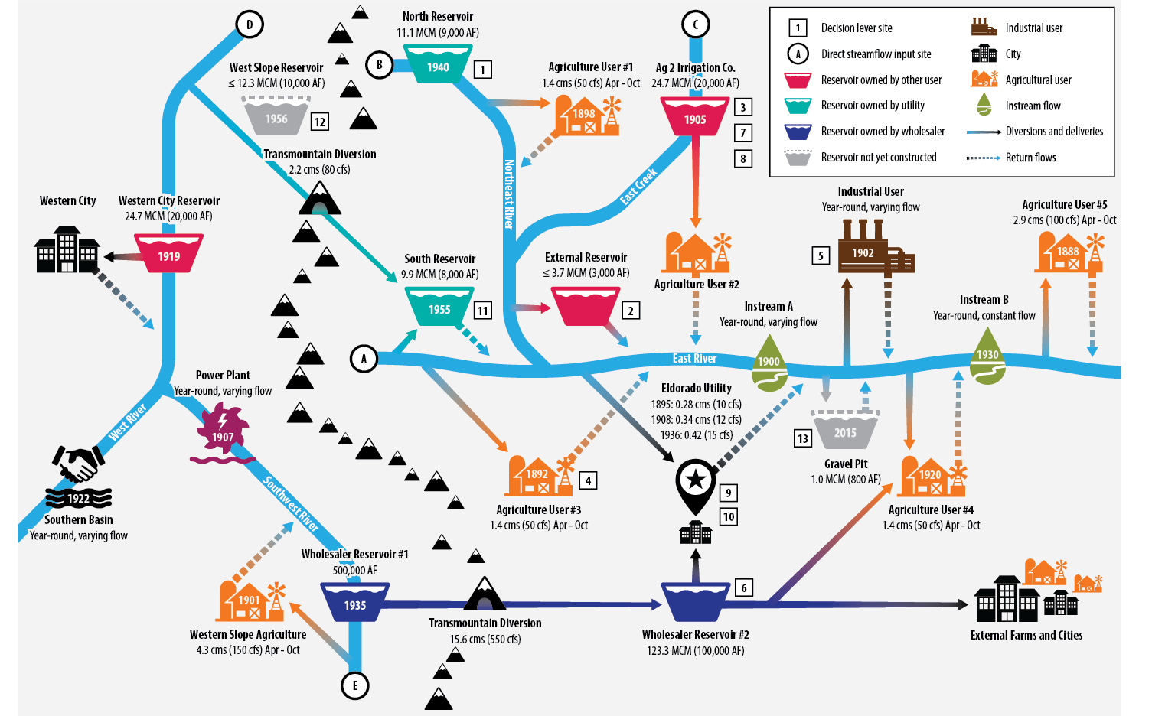

Figure 2. Another depiction of the model

## Eldorado Utility

The Eldorado Utility is a small eastern slope municipal water provider for a hypothetical city whose system features and demands are based loosely on real cities. It currently serves 100,000 customers with an average system use of 550 liters per capita per day (Lpcd) (145 gallons per capita per day – gpcd). This use translates to approximately 20 million cubic meters (MCM) (or 16,200 acre feet – AF) of annual demand if no use restrictions are imposed. The predominant seasonal demand pattern is single family residential, so demand increases substantially during summer months for outdoor ornamental landscape irrigation (31% of total annual use serves these outdoor purposes). The model differentiates between indoor and outdoor use when calculating actual water consumption, where 95% of indoor use returns to the stream and 15% of outdoor use returns to the stream.

To meet current demands, Eldorado owns three eastern slope direct streamflow diversion rights, one transmountain diversion right (transferred under the mountains from the western slope to the eastern slope), two eastern slope reservoirs, and 10,000 wholesaler shares (shares are a term for fixed yields of water provided through the infrastructure and management of an entity other than Eldorado). All diversion and storage water used by the utility is taken from the stream just below the confluence of the Northeast River and the East River. The three diversion rights for 0.28, 0.34, and 0.42 cubic meters per second (cms) (10, 12, and 15 cubic feet per second, cfs) have a range of priorities, from the third most senior date of 1895 to the fourth most junior date of 1936, all from the East River. The 1956 transmountain diversion (**TMD**) right is the most junior right and brings water from the West River under the mountains to be stored in the South Reservoir (SouthRes or **SR**), which is owned by Eldorado. TMD is currently Eldorado’s only reusable water source. SouthRes can hold up to 9.87 MCM (8,000 AF) of eastern or western slope water, and collects East River water for offstream storage with a 1955 priority date. The two sources for this reservoir compete for space, limiting the yields of both rights. Eldorado’s North Reservoir (NorthRes or **NR**) is an 11.1 MCM (9,000 AF) onstream reservoir that stores Northeast River water with a 1940 priority date. The Wholesaler shares are collected on the western slope and stored on both slopes, and Eldorado draws its shares directly from the eastern slope Wholesaler Reservoir 2 (**WS2**).

## Other Model Features

Including the utility, there are nine different water users on the eastern slope of the mountains. The diversion and return flow points for the other water rights holders are often disadvantageous for Eldorado. Eldorado’s two reservoirs are the farthest upstream storage rights, and also the most junior, so eight other senior users draw water away from them for much of the year. For example, Agriculture User #1 (**Ag1**) is located directly downstream of NorthRes on the Northeast River; the farmer has a growing season diversion right (April 1 through October 31) that draws water down the river that Eldorado wants to store. Another example is Agriculture User #3 (**Ag3**), who during the growing season diverts water immediately downstream of SouthRes on the East River. This user also has a return point that is inconvenient for the utility; it is just downstream of Eldorado’s diversion point, meaning the farmer’s unconsumed water cannot increase streamflow at a location that benefits the utility’s opportunity to divert its junior rights. Similarly, Eldorado’s return flow point is just downstream of the 1900 priority date instream flow right (**IsA**), so the utility’s unconsumed water does not help to meet that flow requirement. All of the other users’ priority dates and diversion and return flow points create additional complicated stream dynamics and challenge Eldorado’s ability to access the eastern slope’s limited water supply.

Because Eldorado gets water from the western slope via a diversion right and shares derived from the Wholesaler’s western slope storage right, the model was designed so that these sources also faced competition. The TMD and the Wholesaler’s collection reservoir (**WS1**) are both junior to all of the other water rights on the western slope; these storage, diversion, and instream flow requirement rights limit the yields of the utility’s sources. The details of all water users are presented in Table 1.

Between the east and west slopes of the model, Eldorado has access to 5 different watersheds and competes with 12 other users (some of which are also represented in the *Decision Levers* section as potential supply sharing partners for the utility). Flow magnitudes shrink and grow at various points along the streams’ lengths, and the hydrology varies by basin, season, and year. The priority system, not only physical availability, dictates which users get water and when. Though scaled down, these model characteristics are representative of the conditions faced by many utilities on the Front Range and around the western U.S.

# Decision Levers

Eldorado has 13 decision levers available to address its looming water supply gap. The levers fall into three categories: Enhancing Operations, Acquiring Supply, and Building Storage. The levers described below and their complex interactions with each other were incorporated in response to workshop input from water managers and are directly comparable to the decision spaces that real Front Range utilities operate within (Smith et al., 2017). Table 3 summarizes the levers described below.

## Enhancing Operations

This category includes levers that increase Eldorado’s operational flexibility. The first lever is *Exchange*, which, when chosen, gives Eldorado the legal right to trade its reusable return flows from their downstream return location to an upstream reservoir. The *Exchange* can only operate when the trade will not injure other water rights holders. To facilitate the trading, Eldorado can lease firm (designated) space in an existing reservoir belonging to an unmodeled external user, through a lever called *LeaseVolXRes.* XRes is located halfway upstream between Eldorado’s return point and NorthRes, and, importantly, downstream of Agriculture User #1. When this farmer’s right is in priority, Eldorado can store reusable water in XRes until there is opportunity to trade it up to NorthRes. The amount of XRes storage space available is determined by the volume specified by the *LeaseVolXRes* lever. Another place Eldorado can choose to store reusable return flows is in the Ag2 Irrigation Company reservoir (Ag2Res). If *LeaseAg2Res* is turned on, Eldorado has access to available space in Ag2Res. This is not a fixed volume; it is subject to availability.

## Increasing Supply

These levers are non-infrastructure actions that Eldorado can take to increase the amount of water available to put toward meeting demand. The utility can choose to buy water from Agriculture User #3 (Ag3) using the lever *RightsAg3*. Ag3 has a high-seniority right just below SouthRes on East River. Eldorado can buy up to 20% of this 1.4 cubic meters per second (cms) (or 50 cubic feet per second- cfs) right and store it in SouthRes (after preserving the historic return flow patterns of the farmer’s original usage). Eldorado can also choose to buy up to 20% of Industrial User’s downstream, mid-seniority right through the *RightsIndustrial* lever. After preserving Industrial’s historic return flow patterns, Eldorado may divert the rest of the water directly from the stream. Both of these sources are reusable.

In addition to water rights, Eldorado may also acquire shares of other user’s water. The utility may add up to 6,000 additional Wholesaler shares to its current stock of 10,000 via *SharesWholesaler*. Each share yields approximately 863 cubic meters (0.7 AF) per year, and due to Wholesaler policies, this water is not reusable. The Ag2 Irrigation Co. also operates based on shares; currently they are all owned by Ag2 farmers, but Eldorado may purchase up to 10,000, each of which yields approximately 617 cubic meters (0.5 AF) per year. That yield is reduced by the amount of water necessary to preserve the farmers’ historic return flow patterns, but the water is reusable. Another supply mechanism to help Eldorado recover from droughts is temporarily leasing additional shares from Ag2 Irrigation Co. These shares are “interruptible” because the utility may activate them in any given year when facing low storage conditions. The *SharesInterruptible* lever may option up to 10,000 shares.

Two other levers Eldorado may use to increase available supply are to conserve water and to increase distribution efficiency. Long term conservation measures free up water that would have otherwise not been available to meet future demand, so it is a way to increase supply. *ConsFactor* may be set to no conservation, moderate, or aggressive conservation. Increasing distribution efficiency by, e.g., improving metering or fixing leaks, also reclaims previously-unavailable water. *DistEff* is currently at 90%, but may increase to up to 93% depending on the value of the lever.

## Building Storage

Eldorado has three possibilities for adding permanent storage to its system. It may expand SouthRes from 9.87 MCM (8,000 AF) to up to 12.3 MCM (10,000 AF), so *ExpandVolSouthRes* may be 0 – 2.47 MCM (0 – 2,000 AF). Adding this volume would create more space to store the 1955 East River right, the TMD right, and, potentially, the Ag3 right; all of these sources compete for space in SouthRes. Eldorado can also choose to build a West Slope reservoir (WestSlopeRes), which would store the TMD right on the western slope until it could be stored locally in SouthRes or used to meet demands. *BuildVolWestSlopeRes* may be 0 – 12.3 MCM (0 – 10,000 AF). Finally, Eldorado can choose to develop gravel pits located downstream of its return point. When *GP* is on, the utility has 0.99 MCM (800 AF) in which to store reusable return flows that can help to meet historic return flow patterns or be exchanged upstream.

Table . Summary of decision levers available to Eldorado.

|  |  |  |  |
| --- | --- | --- | --- |
| **Decision** | **Description** | **Units** | **Range** |
| **Enhancing Operations** | | | |
| Exchange | Acquire right to exchange reusable return flows to NorthRes | --- | 0 - 1 |
| LeaseVolXRes | Pay owners of XRes to lease dedicated space that can facilitate Exchange | MCM  (AF) | 0 – 3.7  (0 - 3,000) |
| LeaseAg2Res | Pay Ag2 Irrigation Co. to store water in any available unused space; 0 = off, 1 = on | --- | 0 - 1 |
| **Increasing Supply** | | | |
| RightsAg3 | Purchase a portion of Ag3’s senior diversion right | % | 0 - 20 |
| RightsIndustrial | Purchase a portion of Industrial user’s mid-seniority diversion right | % | 0 - 20 |
| SharesWholesaler | Purchase additional shares of Wholesaler water | shares | 0 - 6,000 |
| SharesAg2 | Purchase shares of Ag2 Irrigation Co. water | shares | 0 - 10,000 |
| SharesInterruptible | Negotiate agreement with Ag2 Irrigation Co. for optional supply leases | shares | 0 - 10,000 |
| ConsFactor | Reduce starting per capita demand through conservation measures; 0 = no change, 1 = 10% reduction, 2 = 20% reduction | --- | 0 - 2 |
| DistEff | Improve distribution efficiency by reducing unaccounted-for water (e.g. fixing leaks, improving metering, etc.) | % | 90 - 93 |
| **Building Storage** | | | |
| ExpandVolSouthRes | Expand SouthRes | MCM  (AF) | 0 – 2.47  (0 – 2,000) |
| BuildVolWestSlopeRes | Build WestSlopeRes | MCM  (AF) | 0 – 12.3  (0 - 10,000) |
| GP | Develop gravel pits to store reusable return flows downstream of the city; 0 = not developed, 1 = developed | --- | 0 - 1 |

# Importing data

There are two categories of input to EUPM: decision lever inputs and hydrology (scenario) inputs. The model will run without executing any input DMIs because it is saved with values populating the input slots, but to change attributes of Eldorado’s system or the hydrologic scenario under which it is simulated, you need to execute DMIs. There are two types of input DMIs already defined in the model: Control File-Executable (ctl file) DMIs and Trace Directory (traces) DMIs.

## Ctl file input DMIs

Ctl file DMIs require a text file with the extension .ctl that specifies (at minimum) the target slots and the text files to be read in as the input values. Decision lever input values are all imported using ctl file DMIs.

There are two directories for decision lever inputs: “input” and “OGinput”. These are further explained below, but each directory contains the .ctl file and 13 text files corresponding to the values that will be read into the decision lever input slots.

### DecLeverInput

This DMI refers to the “input” directory which has the .ctl file and the 13 decision lever text files. If you run this DMI it will set all decision lever slots to the values specified in the text files. When run with the MOEA, these text files would be altered for each function evaluation and then read into the model to test different portfolios. However, the files can be altered by hand to test different configurations of the Eldorado Utility’s system.

### OG Dec Levers

This DMI refers to the “OGinput” directory which has the .ctl file and the 13 decision lever text files. If you run this DMI it will set all decision lever slots to their original values (i.e. a baseline before Eldorado enacts any portfolio decisions).

## Traces input DMIs

Traces DMIs enable RW users to house multiple scenarios under a single directory for more efficient organization and execution of scenarios that have multiple input traces. There are 10 individual traces for each of the 5 hydrologic scenario originally developed to drive EUPM, and changing the hydrologic scenario requires making changes to 17 slots within the model.

In the “scenario” directory there are five directories that correspond to each of these scenarios, and within each of these subdirectories there is a folder for each of the 10 traces. Finally, within each trace folder there are 17 text files that contain timeseries or periodic values for each of the slots that are affected by alterations in hydrologic scenario. It is important that all of the different scenario directories maintain exactly the same structure (i.e. within the folder there is “Trace1”, “Trace2”, etc. and then within each trace folder the input text files must have the same naming scheme).

Creating traces DMIs in RW requires specification of a traces .ctl file. For the EUPM, this is the “HydroTracesWithEvapInput.ctl” file which should be located in the $ELDO directory (this is the directory above the “scenarios” directory). Each trace DMI refers to this control file and also refers to the “top directory” which is the specific scenario that contains the trace folders.

Traces DMIs are used in the EUPM Multiple Run Managers (MRMs) (described in a later section), but they can be run to import individual traces of a scenario by opening the DMI and specifying the trace number, hitting “OK”, and then running the DMI.

There is a traces DMI for each of the 5 scenarios:

“Historic_Hydro10”

“HistoricPlus_Hydro10” (the lowest 10% of historic annual flow volumes are twice as likely to occur)

“CC1C_Hydro10” (historic record is perturbed with monthly deltas from a 1C warmer future)

“CC4C_Hydro10” (historic record is perturbed with monthly deltas from a 4C warmer future)

“Varied_Hydro10” (a set of 10 traces drawn from the other 4 scenarios: 4 from Historic, 2 from HistoricPlus, 3 from CC1C, and 1 from CC4C)

# Exporting data

There are two types of output DMIs in the model: a Traces output DMI and Database (Excel) DMIs.

## Ctl file output DMIs

The “ObjectivesOutput” DMI is directed by the “$ELDO/output/SingleTrace/BorgOutput_control.12obj.2const.SingleTrace.ctl” file located in the output/SingleTrace folder. This DMI should be run by hand (not in an MRM) and will write a text file for each of the slots specified in the .ctl file. These text files will be written to the output/SingleTrace folder. This DMI outputs the same slots as those in the “ObjectivesOutputTraces” and “ObjectivesOutputForExcel” DMIs.

## Traces output DMI

The “ObjectivesOutputTraces” DMI is a traces DMI that writes slot values to a set of trace folders located in the “output” folder. This works exactly like the Traces input DMIs described above. There is a file called “OutputObjectivesTracesDMI.ctl” in the outermost testbed directory that specifies which RW slots are output and the names of the text files that they create. A set of each of the text files will be written to each of the trace folders (or, if run outside of an MRM, the files will be written to whichever trace folder is specified in the “Trace to use outside of MRM” filed in this DMI’s dialogue. Note that it only makes sense to run this DMI while using the MRM because it will otherwise just output whatever values are currently sitting in the slots, which may not be representative of performance in the trace specified.

## Excel DMIs

Besides the original MOEA objectives slots, others were created to further analyze portfolios. For some of these slots, the “ResilienceExcel” Excel DMI outputs values. When you open this DMI, if you double click on the green header you will open a dialogue that gives you information about how the outputs are formatted and where to find the resulting Excel file.

“ObjectivesOutputForExcel” is an Excel DMI that outputs the MOEA objectives slots to an Excel sheet in the same way as the Resilience DMI.

Note that these output DMIs will not execute properly in a distributed MRM, but will execute in an MRM if you simulate one trace at a time.

# MRMs

Automated simulation of multiple traces within a scenario is accomplished with MRMs. In the MRM dialogue there are several already created. Each one specifies how the runs (simulations) will incorporate input and output DMIs, which ruleset to use, how many traces to run, and whether to distribute the runs across multiple computing cores.

## Optimization MRMs

There is an MRM for each of the 5 hydrologic scenarios (all begin with “Optimization” in their names). These are all designed to initialize a run with the decision lever values (DecLevInput is specified as the initialization input DMI); they use the 10 traces associated with their respective scenarios (see name of Input DMI); there is only one ruleset (all MRMs use it); these MRMs use all 10 traces from the ObjectivesOutputTraces DMI to export values from the objectives slots for each simulated hydrologic trace. The MRMs execute concurrently and the simulations are distributed across as many cores as are available. You can change the output DMI to ResilienceExcel of ObjectivesOutputForExcel but if you should uncheck the Distributed Runs box located at the bottom right of the MRM Configuration dialogue’s Input tab because these DMIs will not work with distributed runs. You can also change the number of hydrologic traces (and then the ObjectivesOutputTraces DMI will also only execute for the traces specified).

## Other MRMs

There are two other MRMs: “Resilience” and “ObjectivesOutputForExcel”. They were originally designed to be run more interactively than the optimization MRMs. Thus, they do not run an initialization input DMI (they will use whatever values for decision lever slots are already loaded into the model) and they are not associated with a specific hydrologic scenario (the input DMI was changed as necessary for certain analyses). They use the ResilienceFrorExcel and ObjectivesOutputForExcel output DMIs, respectively. Like the optimization MRMs, they are currently set to run all 10 traces of a scenario and distribute the concurrent runs across cores.

# Input data

Objectives slots (the ones specified in the control files, but mention that there are many other slots on the data objects that could also be output)

## Hydrologic scenario inputs

Each hydrologic scenario includes inputs for 17 slots. Below is a brief description of the data and slots. The rationale and processes of developing the scenario-specific inputs can be found in [external documents].

There are five headwaters input sites in the model. For each of the hydrologic scenarios, a 25-year-long streamflow timeseries is imported to the slots below:

Slot names:

Mainstem1.Local Inflow (aka East River)

NorthFork1.Local Inflow (aka Northeast River)

NorthCreek1 (aka North Creek)

NorthWestSlope1 (aka West River)

SouthWestSlope1.Local Inflow (aka Southwest River)

The model has two water rights on the western slope (PowerPlant and LowerBasin) that are modeled as rights that are far downstream of the rest of the users. To be able to incorporate these rights that would have intervening water sources if the hypothetical model incorporated a larger area, proportions of model water that need to be contributed are calculated based on relationships between sets of real world streamflow records. In order to maintain appropriate relationships for each hydrologic scenario, three other perturbed timeseries of data other than the headwater sites are included in hydrologic input DMIs:

Slot names:

LowerBasinData.LeesFerryFlow

PowerPlantData.GlenwoodSpringsFlow

LowerBasinData.LFAnnualProportions

Finally, the climate change scenarios developed for the model are based on temperature increases. Increasing temperatures will likely result in increased evaporation from reservoirs, so each of the 9 reservoirs in the model gets a set of monthly evaporation coefficients that change depending on the scenario.

Slot names:

Res1.Evaporation Coefficients (aka NorthRes)

Res2.Evaporation Coefficients (aka SouthRes)

Ag2Res.Evaporation Coefficients

ExternalRes.Evaporation Coefficients

WholesalerRes2.Evaporation Coefficients

WholesalerRes1.Evaporation Coefficients

WestSlopeMunicipalRes.Evaporation Coefficients

WestSlopeRes.Evaporation Coefficients

GravelPit.Evaporation Coefficients

## Decision lever inputs

|  |  |  |  |  |
| --- | --- | --- | --- | --- |
| **Name of decision lever from Table 2** | **Name of input text file** | **Name of slot** | **Range** | **Notes** |
| SharesWholesaler | AdditionalWholesalerShares.txt | UtilityData.SupplementalWSShares | 0 – 10,000 |  |
| SharesAg2 | Ag2PurchasedShares.txt | UtilityData.Ag2PurchasedShares | 0 or 160 – 10,000 | *Any value from 1 to 159 will cause the model to abort b/c it messes up Ag2Res operations |
| LeaseAg2Res | Ag2ResIfWhen.txt | UtilityExchanges.Ag2ResIfWhen | 0 or 1 |  |
| RightsAg3 | Ag3Purchase.txt | UtilityData.PercentageOfAg3Rights | 0 – 0.2 |  |
| ConsFactor | ConservationFactor.txt | UtilityData.ConservationFactor | 0 or 1 or 2 |  |
| DistEff | DistributionEfficiency.txt | UtilityData.DistributionEfficiency | 0.9 – 0.93 |  |
| GP | GravelPitOnOff.txt | UtilityExchanges.GravelPitOnOff | 0 or 1 |  |
| RightsIndustrial | IndustrialPurchase.txt | UtilityData.PercentageOfIndustrialRights | 0 – 0.2 |  |
| SharesInterruptible | IWSAShares.txt | UtilityData.Ag2IWSAShares | 0 – 10,000 |  |
| ExpandVolSouthRes | Res2EV.txt | Res2.Elevation Volume Table.Storage | 8,000 – 10,000 | *Text file must have a top row of “0” and the next row as the capacity in AF  *the “.Storage” indicates a column in the table |
| Exchange | RFtoRes1.txt | UtilityExchanges.RFtoRes1 | 0 or 1 |  |
| BuildVolWestSlopeRes | WestSlopeResCapacity.txt | UtilityTMDData.WestSlopeResCapacity | 0 – 10,000 |  |
| LeaseVolXRes | XResCapacity.txt | UtilityExchanges.XResCapacity | 0 – 3,000 |  |

# Output data

The first seven objectives in the OutputObjectives DMIs are those that were used in an MOEA-assisted optimization study completed in 2017. All of these slots custom calculations that can be found on the ObjectivesAndContraints data object within the model. In the model, the slots have expressions that describe how they are calculated. For further reading about these objectives, see [external doc]. The slot names below map exactly to the names of the output textfiles that result from executing the DMIs.

Output slots:

ObjectivesAndConstraints.NumberOfYearsInRestriction1

ObjectivesAndConstraints.NumberOfYearsInRestriction2

ObjectivesAndConstraints.NumberOfYearsInRestriction3

ObjectivesAndConstraints.AvgMissedOpWaterPerYear

ObjectivesAndConstraints.AvgSupplyCreatedPerYear

ObjectivesAndConstraints.NewlyDevelopedStorage

ObjectivesAndConstraints.NEGMinimumMarchStorageToAnnualDemandRatio

Other slots are also targeted as outputs which, in the .ctl files, are termed “extra objectives” or “constraints”. They correspond to other calculated slots on the same data object. There are a variety of other slots on that data object as well as on the PostOptimizationPortfolioCalcs data object that can be exported. Additionally, you may create your own custom calculations to evaluate the system or export slots that come standard with RW.